**Project Design Phase**

**Solution Architecture**

|  |  |
| --- | --- |
| Date | 20 February 2026 |
| Team ID | TVIP2026TMIDS41611 |
| Project Name | OrderOnTheGo: Your On-Demand Food Ordering Solution |
| Maximum Marks | 4 Marks |

**Solution Architecture:**

**Solution Architecture (OrderOnTheGo)**

* OrderOnTheGo follows a layered, role-based web architecture:
* Client Layer → Frontend Layer → Backend API Layer → Data & Integration Layer.
* Client Layer: four actors use the same app with different permissions — USER, RESTAURANT, STAFF, ADMIN.

**Core Layers**

* Frontend (React + Vite + Tailwind): single-page app with role-specific dashboards and flows; communicates with backend via secure REST calls.
* Backend (Node.js + Express): modular APIs for auth, restaurants, menu/foods, cart, orders, payments, reviews, staff invites, subscriptions, verification, and admin analytics.
* Data Layer (MongoDB + Mongoose): persistent storage for users, restaurants, foods, carts, orders, payments, reviews, staff invites, subscriptions, and status requests.
* External Services: Razorpay (payments), SendGrid (email), Twilio (SMS), and image upload storage.

**How Data Flows**

* Users browse menus and place orders through the frontend; backend validates identity/role, processes business rules, and updates MongoDB.
* Payments go through Razorpay, then backend verifies signatures and updates payment/order states.
* Verification and notifications are handled asynchronously via SendGrid/Twilio.
* Admin analytics aggregate operational data (orders, revenue, subscriptions) from MongoDB for dashboards**.**

**Architecture Strengths**

* Clear separation of concerns, reusable API modules, centralized security (JWT + RBAC), and easy scalability by expanding backend services or splitting modules into microservices later.

**Solution Architecture Diagram:**

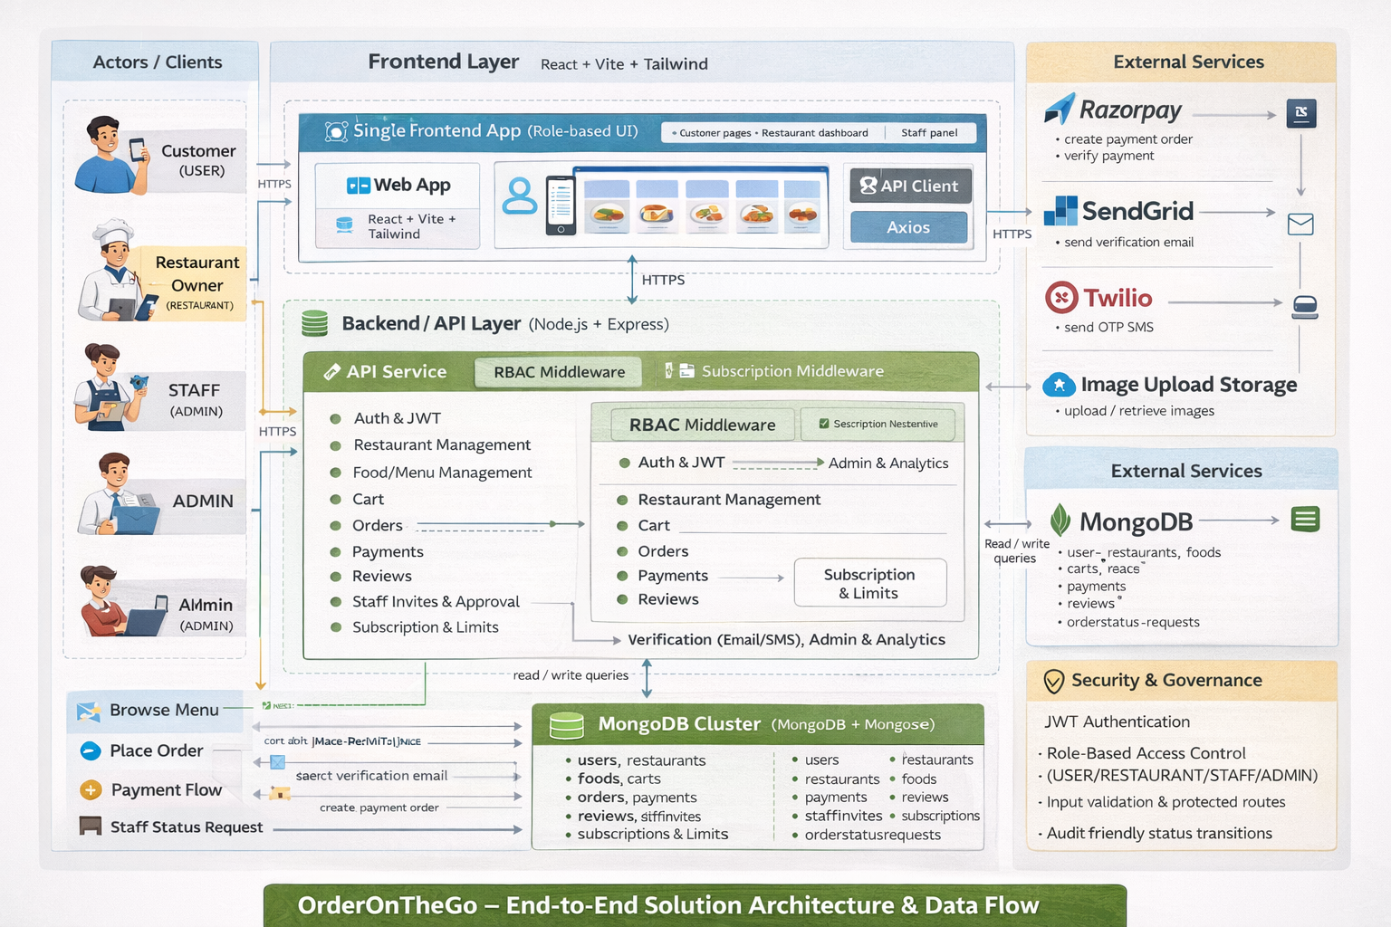

*Figure 1: Architecture and data flow of OrderOnTheGo*

**Reference:** [**https://aws.amazon.com/blogs/industries/voice-applications-in-clinical-research-powered-by-ai-on-aws-part-1-architecture-and-design-considerations/**](https://aws.amazon.com/blogs/industries/voice-applications-in-clinical-research-powered-by-ai-on-aws-part-1-architecture-and-design-considerations/)